National University of Technology

Computer Science Department
Fall Semester – 2024
LAB Report-5
Course: Computer Networking

Submitted To: Submitted By:
Name: Maj Abdul Moeed Rao Name: Muhamad Zaheer
CS-A 2023 Reg No: F23605043

Task 1 Subnetting and Network Design
1st Floor:
- Subnet: 192.168.1.0/24
  - The /24 means the first 24 bits are the network part. This allows for 254 usable IP addresses.
- IP Range: 192.168.1.1 - 192.168.1.254
  - Devices will use these addresses to communicate.
- Hosts: 254
- This means up to 254 devices can be connected
- Subnet Mask: 255.255.255.0
2nd Floor:
- Subnet: 192.168.2.0/25
  - The /25 allows for 126 usable IP addresses.
- IP Range: 192.168.2.1 - 192.168.2.126
  - The devices will use these addresses.
- Hosts: 126
  - This allows up to 126 devices to connect.
- Subnet Mask: 255.255.255.128
3rd Floor:
- Subnet: 192.168.3.0/26
  - The /26 means 62 usable IP addresses.
- IP Range: 192.168.3.1 - 192.168.3.62
  - Devices on this floor will use these addresses.
- Hosts: 62
  - 62 devices can connect.
- Subnet Mask: 255.255.255.192

4th Floor:
- Subnet: 192.168.4.0/27
  - The /27 allows for 30 usable IP addresses.
- IP Range: 192.168.4.1 - 192.168.4.30
  - These addresses will be used by devices on this floor.
- Hosts: 30
  - 30 devices can connect.
- Subnet Mask: 255.255.255.224

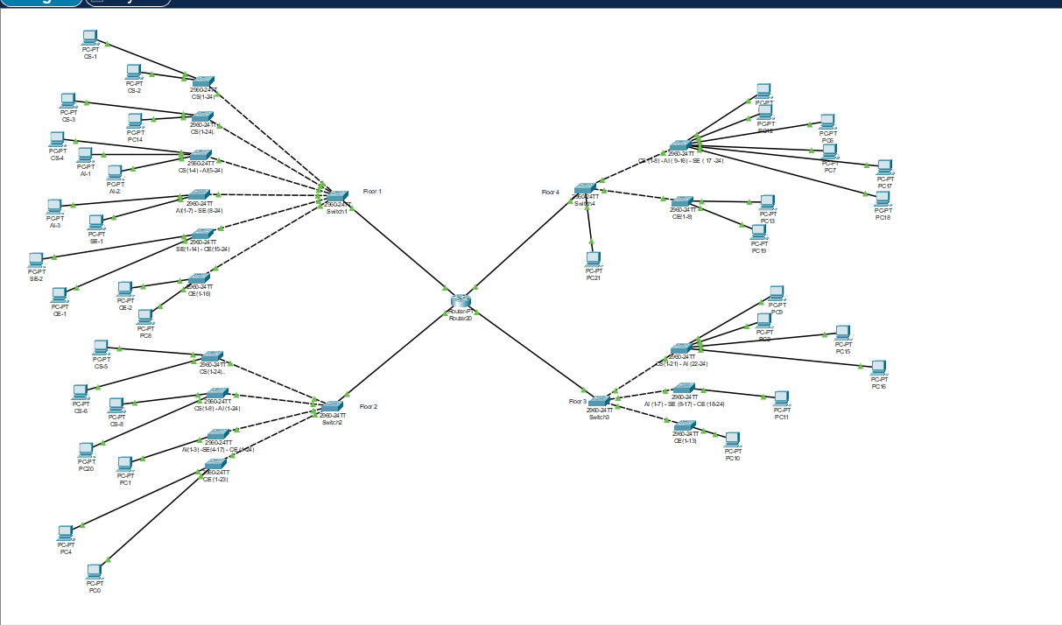

Ping of PCs of different Floors before creating VLAN

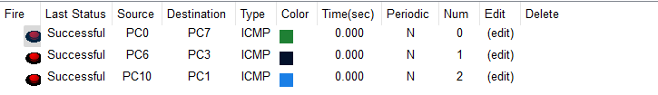
Summary
With VLSM, we created subnets that closely match each floor’s requirements, optimizing IP usage. Here is the table:

Floor | Hosts Needed | Subnet Mask | Number of IPs | Subnet Address
1st Floor | 136 | /24 | 254 | 192.168.1.1/24
2nd Floor | 95 | /25 | 128 | 192.168.2.1/25
3rd Floor | 51 | /26 | 64 | 192.168.3.128/26
4th Floor | 32 | /27 | 32 | 192.168.4.192/27

Comparison of FLSM vs. VLSM
- FLSM: Would require a /22 subnet (255.255.254.0) for each floor to ensure all host requirements are met, resulting in IP wastage.
- VLSM: Optimizes IP address allocation by using different subnet sizes that fit each floor’s host requirements, reducing wastage.
Conclusion
Using VLSM is more efficient in this scenario as it saves IP addresses and meets the needs of each floor precisely.

Task 2

Task 2 is not complete. Only PC’s that are part of first VLAN which is CS (10). Will be able to communicate with each other.

VLAN Subnetting Plan
VLAN for CS (52 hosts)
- Required IPs: 52 + some extra for future expansion
- Subnet: 192.168.1.0/26
  - Subnet Mask: 255.255.255.192
  - Range: 192.168.1.0 - 192.168.1.63
  - Sub-interface: FastEthernet0/0.10
  - Example IPs:
    - Sub-interface: 192.168.1.1
    - Hosts: 192.168.1.2 - 192.168.1.62
  - Network IP: 192.168.1.0
  - Broadcast IP: 192.168.1.63
VLAN for AI (27 hosts)
- Required IPs: 27 + some extra for future expansion
- Subnet: 192.168.1.64/27
  - Subnet Mask: 255.255.255.224
  - Range: 192.168.1.64 - 192.168.1.95
  - Sub-interface: FastEthernet0/0.20
  - Example IPs:
    - Sub-interface: 192.168.1.65
    - Hosts: 192.168.1.66 - 192.168.1.94
  - Network IP: 192.168.1.64
  - Broadcast IP: 192.168.1.95
VLAN for SE (31 hosts)
- Required IPs: 31 + some extra for future expansion
- Subnet: 192.168.1.96/27
  - Subnet Mask: 255.255.255.224
  - Range: 192.168.1.96 - 192.168.1.127
  - Sub-interface: FastEthernet0/0.30
  - Example IPs:
    - Sub-interface: 192.168.1.97
    - Hosts: 192.168.1.98 - 192.168.1.126
  - Network IP: 192.168.1.96
  - Broadcast IP: 192.168.1.127
VLAN for CE (26 hosts)
- Required IPs: 26 + some extra for future expansion
- Subnet: 192.168.1.128/27
  - Subnet Mask: 255.255.255.224
  - Range: 192.168.1.128 - 192.168.1.159
  - Sub-interface: FastEthernet0/0.40
  - Example IPs:
    - Sub-interface: 192.168.1.129
    - Hosts: 192.168.1.130 - 192.168.1.158
  - Network IP: 192.168.1.128
  - Broadcast IP: 192.168.1.159
These configurations ensure that each VLAN has its own network segment, with appropriate IP address ranges, subnet masks, network IPs, and broadcast IPs.

